**Team Name : HLSSS**

**Project Title:** **Intelligent Robot using IBM Watson Platform**

**Aim:** To create an intelligent robot that can be operated from anywhere using

an application.

**Abstract:**

Intelligent Robot using IBM Watson Platform is a cloud connected robot that can be deployed anywhere and control from anywhere using an application that can be used in many fields in monitoring different areas.

Here we are using IBM Watson services to control the robot. The basic functionality of the robot is to move in different directions like left, right, etc. by using an application.

Next functionality is to take a diversion by glowing a led when it finds an obstacle in it s way and when the light around is low again two led s glow as the head lights .

Later all these commands can be operated using voice commands too.

**Software Components:**

1. Arduino IDE
2. Node-RED
3. MIT App Inventor
4. IBM Watson Platform
5. IBM Watson Conversation Services

**Hardware Components :**

1. Node MCU – 1
2. RC Car - 1
3. DC motors -2
4. LDR – 1
5. Led s – 4
6. Ultra Sonic sensor – 1
7. Jumper wires
8. Micro Phone - 1
9. Voice module – 1

**Block Diagram:**

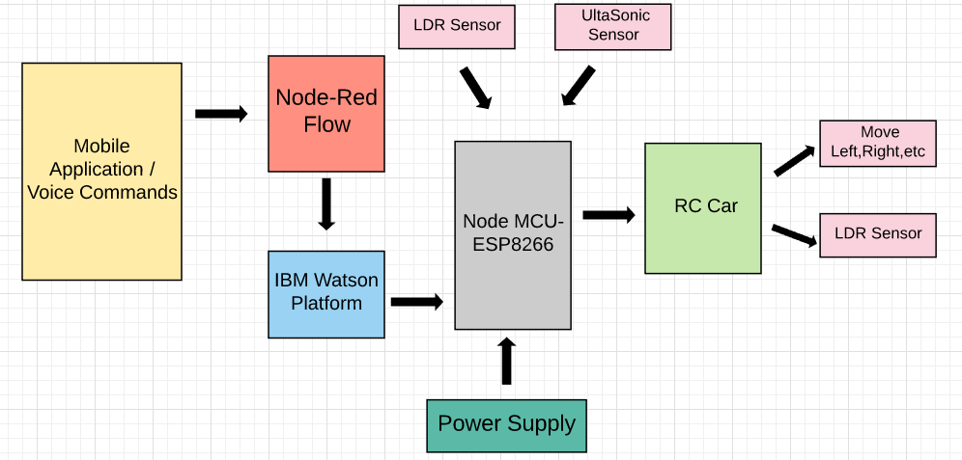

**ESP8266 Node MCU**

**DESCRIPTION:**

NodeMCU is an open-source firmware and development kit that helps you to prototype or build IoT product. It includes firmware which runs on the ESP8266 Wi-Fi SoC from Espressif Systems, and hardware which is based on the ESP-12 module. The firmware uses the Lua scripting language. It is based on the eLua project, and built on the Espressif Non-OS SDK for ESP8266.

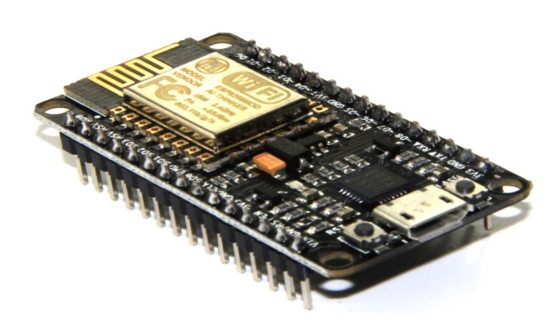

MCU stands for MicroController Unit - which really means it is a computer on a single chip. A microcontroller contains one or more CPUs (processor cores) along with memory and programmable input/output peripherals. They are used to automate automobile engine control, implantable medical devices, remote controls, office machines, appliances, power tools, toys etc.

**PINS OF NODEMCU:**

General-purpose input/output (GPIO) is a pin on an IC (Integrated Circuit). It can be either input pin or output pin, whose behavior can be controlled at the run time.

NodeMCU Development kit provides access to these GPIOs of ESP8266. The only thing to take care is that NodeMCU Dev kit pins are numbered differently than internal GPIO notations of ESP8266 as shown in below figure and table. For example, the D0 pin on the NodeMCU Dev kit is mapped to the internal GPIO pin 16 of ESP8266.

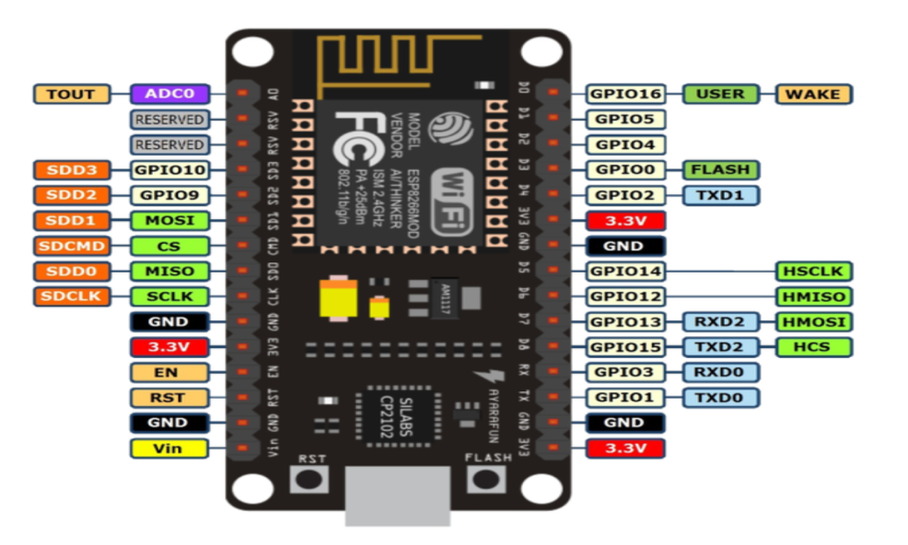

**NodeMCU DevKit GPIOs**

Below table gives NodeMCU Dev Kit IO pins and ESP8266 internal GPIO pins mapping

| **Pin Names on NodeMCU Development Kit** | **ESP8266 Internal GPIO Pin number** |
| --- | --- |
| D0 | GPIO16 |
| D1 | GPIO5 |
| D2 | GPIO4 |
| D3 | GPIO0 |
| D4 | GPIO2 |
| D5 | GPIO14 |
| D6 | GPIO12 |
| D7 | GPIO13 |
| D8 | GPIO15 |
| D9/RX | GPIO3 |
| D10/TX | GPIO1 |
| D11/SD2 | GPIO9 |
| D12/SD3 | GPIO10 |

The GPIO’s shown in blue box (1, 3, 9, 10) are mostly not used for GPIO purpose on Dev Kit.ESP8266 is a system on a chip (SoC) design with components like the processor chip. The processor has around 16 GPIO lines, some of which are used internally to interface with other components of the SoC, like flash memory.Since several lines are used internally within the ESP8266 SoC, we have about 11 GPIO pins remaining for GPIO purpose.

Now again 2 pins out of 11 are generally reserved for RX and TX in order to communicate with a host PC from which compiled object code is downloaded. Hence finally, this leaves just 9 general purpose I/O pins i.e. D0 to D8.As shown in above figure of NodeMCU Dev Kit. We can see RX, TX, SD2, SD3 pins are not mostly used as GPIOs since they are used for other internal process. But we can try with SD3 (D12) pin which mostly like to respond for GPIO/PWM/interrupt like functions.

Note that D0/GPIO16 pin can be only used as GPIO read/write, no special functions are supported on it.

**ULTRA SONIC SENSOR:**

The Ultrasonic sensor(HC-SR04) uses ultrasonic waves to determine distance to an object. It offers non-contact range detection with high accuracy. IT is having two modules transmitter and receiver along with four pins VCC, Trigger (INPUT), Echo (OUTPUT),GND. In this project the Ultrasonic sensor is used to identify and obstacle while the robot is moving.

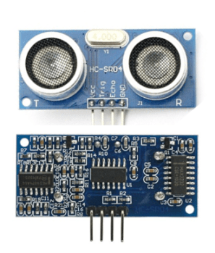

**HOW DOES IT WORKS?**

The transmitter(trig pin) sends a signal with a high-frequency sound.

And when the signal finds an object in it way, it is reflected and the transmitter(echo pin) receives it.

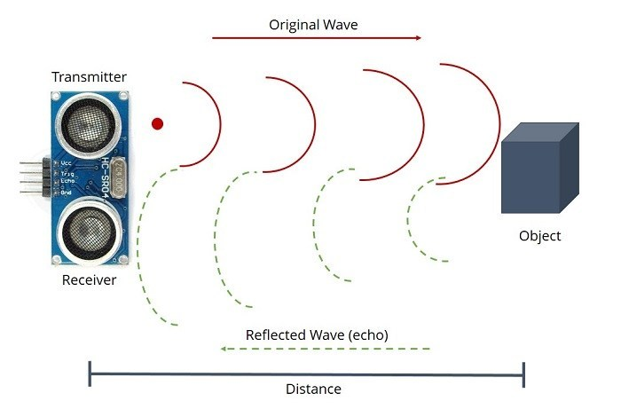

**DISTANCE CALCULATION:**

The distance can be calculated with the following formula:

**Distance L = 1/2 × T × C**

where L is the distance, T is the time between the emission and reception, and C is the Ultrasonic speed.

**SPECIAL FEATURES:**

1. Transparent Object Detectability
2. Resistant to dirt and mist
3. Detectable to complex objects

**RC CARS:**

Radio-controlled or remote-controlled toys, popularly called RC Cars, are self-powered and can be controlled from a distance using a remote that works with radio waves.

**PARTS OF RC CAR:**

Transmitter: The remote control contains a radio transmitter which operates on a particular frequency that the receiver is designed to receive.



Receiver: The receiver is fixed within the car and constantly receives signals from the transmitter. When a transmission is identified, it translates the number of electrical pulses into action.



Power source: All remote control cars require a power source. Rechargeable batteries power small electric motors. Alternatively, some use small internal combustion engines.



Motor and Circuit Board: The motor is responsible for the turning motions of the toy while the circuit board works like a pool through which all commands go on to specific parts.



**HOW DOES IT WORKS?**

When we push the control, the transmitter sends a specific number of electrical pulses corresponding to that action through the air. The transmitter has its own power source, usually in the form of a 9-volt battery. Without the battery, the transmitter will not be able to send the radio waves to the receiver.

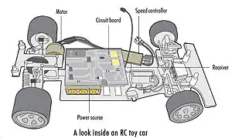

2. Once the RC toy receives the radio waves, the motors kick into life to cause a specific action to occur. The power source sends power to all working parts, including the motor. The transmitter enables control through radio waves and the receiver activates the motors. When we press a button on the transmitter to make the RC toy go forward or backward, a pair of electrical contacts touch. Receiver identifies signals, sends it to circuit.

3. Circuit board translates the number of electrical pulses (signals) into action. Full-function controllers have six controls and these works through following the pulse sequences:

1. Forward: 16 pulses

2. Reverse: 40 pulses

3. Forward left: 28 pulses

4. Forward right: 34 pulses

5. Reverse left: 52 pulses

6. Reverse right: 46 pulses

**DC MOTOR:**

THEDC motor is a machine that transforms electric energy into mechanical energy in form of rotation. Its movement is produced by the physical behavior of electromagnetism. DC motors have inductors inside, which produce the magnetic field used to generate movement

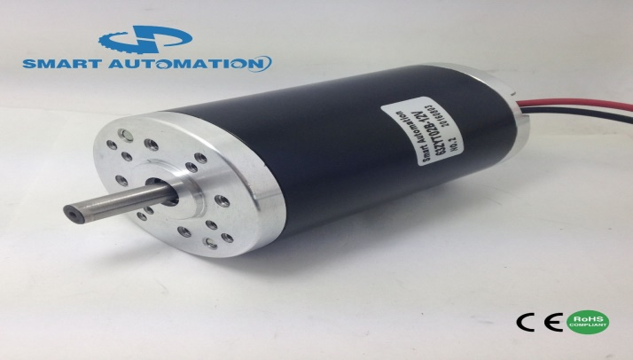

**L293D IC:**

A dual H-bridge motor driver IC, that can drive two motor simultaneously. L293D is a 16 pin IC having two enable pins which should always be remain high to enable both the H-bridges. Pins on the Right Hand Side of the IC are for controlling one motor. And Pins on the Left Hand Side of the IC are for controlling second motor.

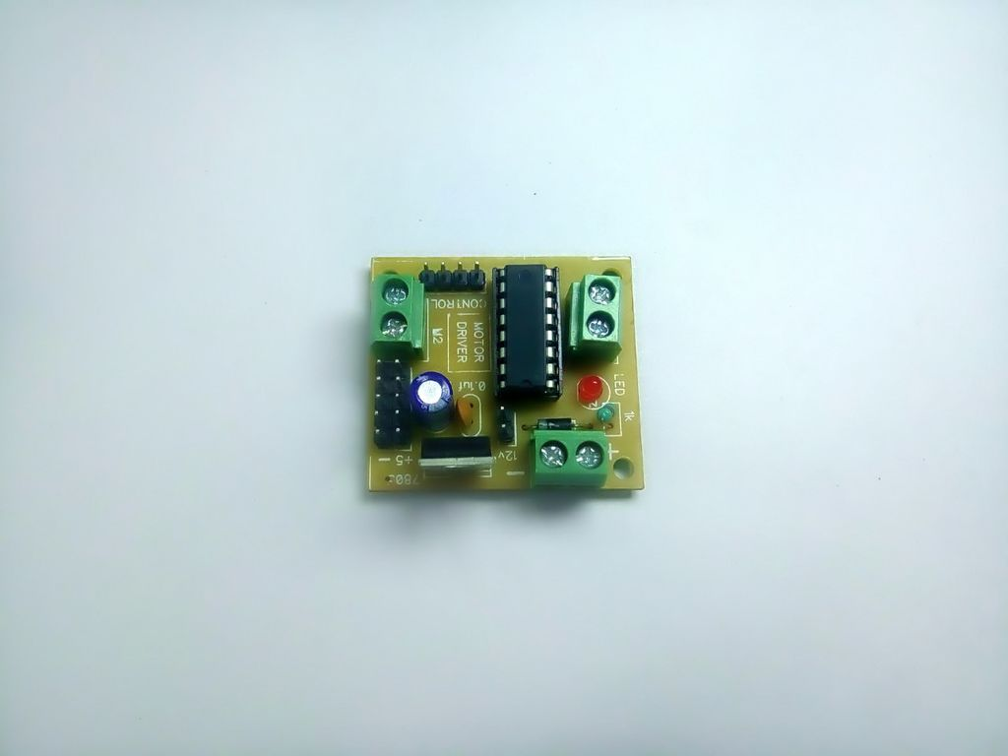

**LDR :**

A Light Dependent Resistor (LDR) is also called a photo resistor or a cadmium sulfide (CdS) cell. It is also called a photoconductor. It is basically a photocell that works on the principle of photoconductivity. The passive component is basically a resistor whose resistance value decreases when the intensity of light decreases.

Daylight = 5000Ω and Dark = 20000000Ω

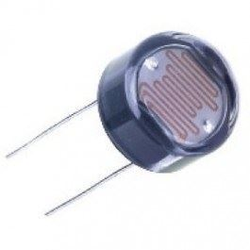

**CIRCUIT DAIGRAM:**

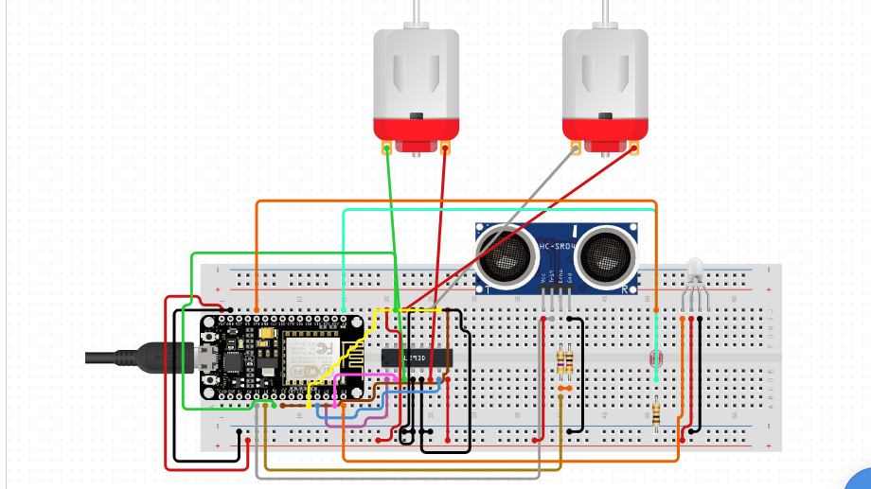

**CODE SCREENSHOTS:**

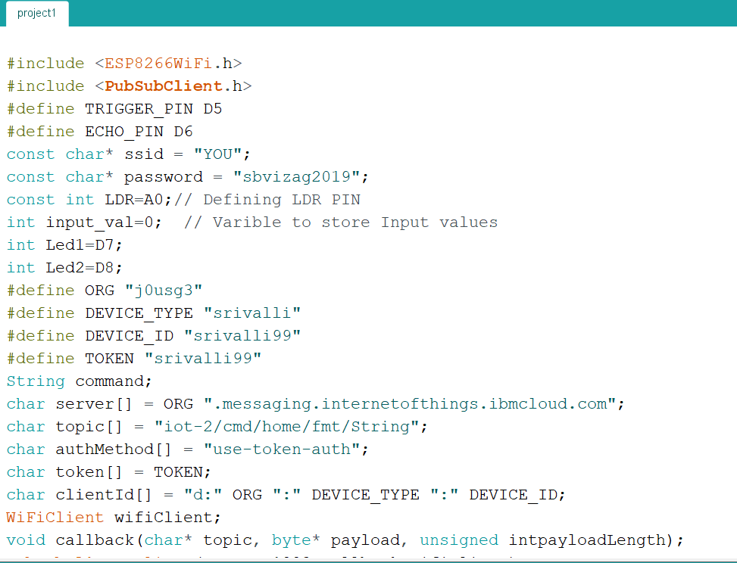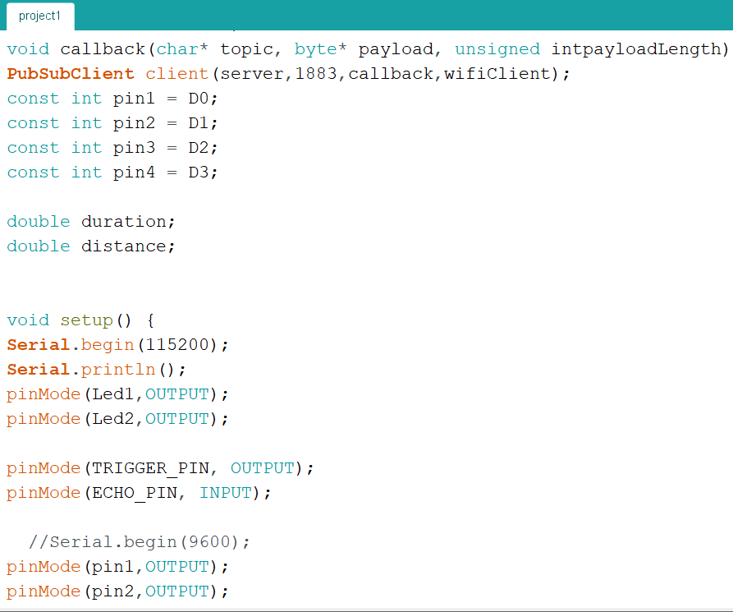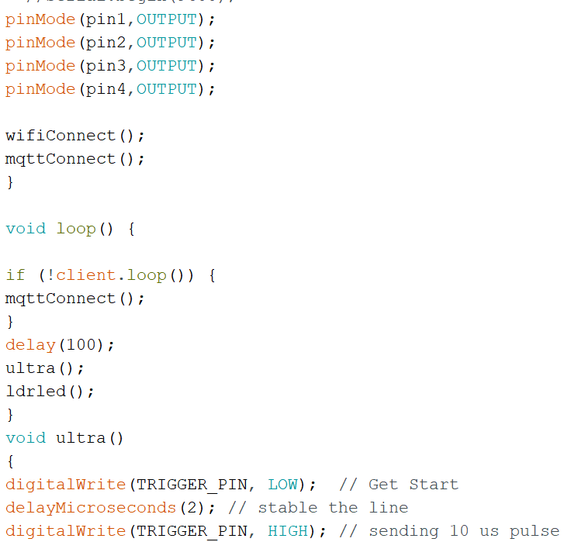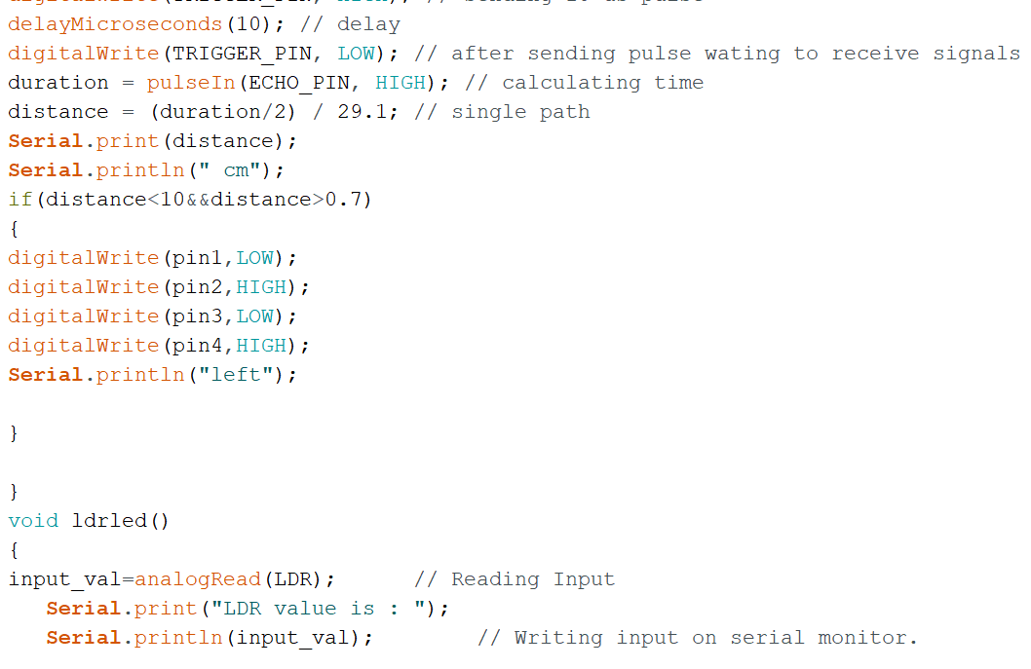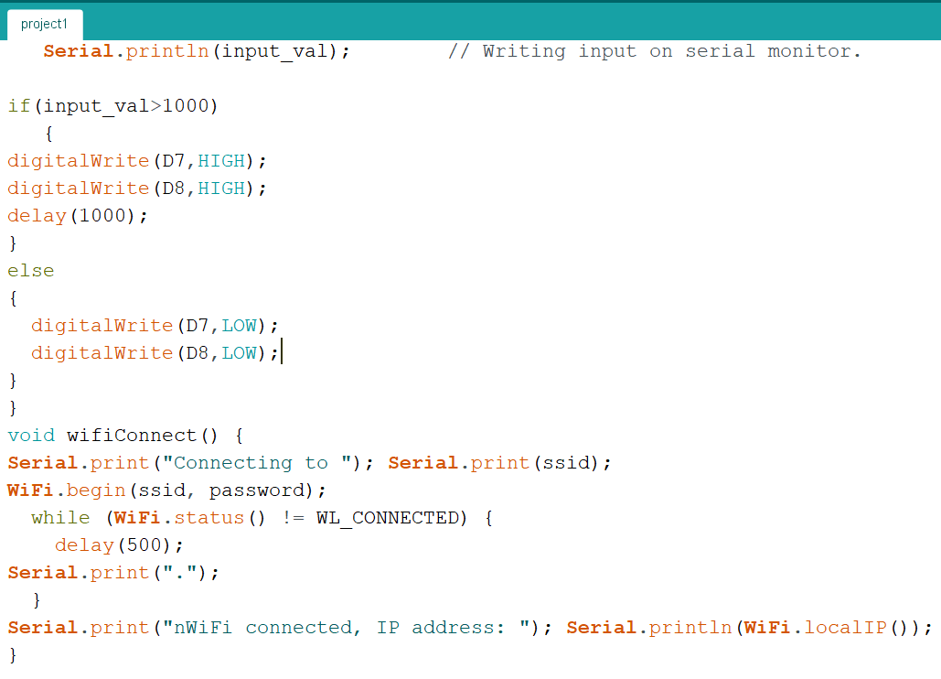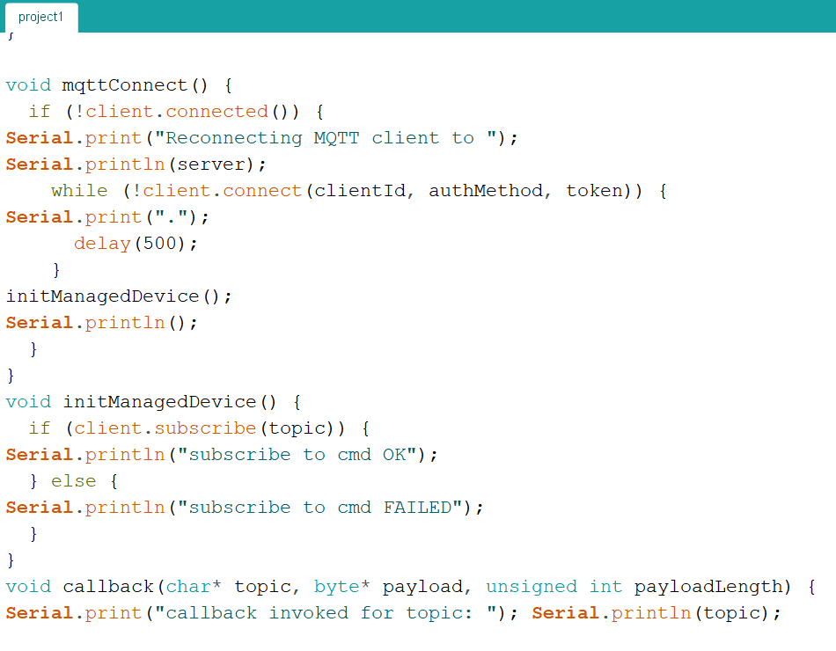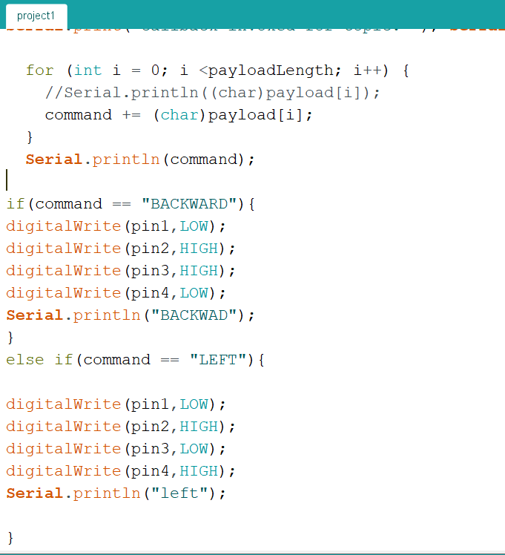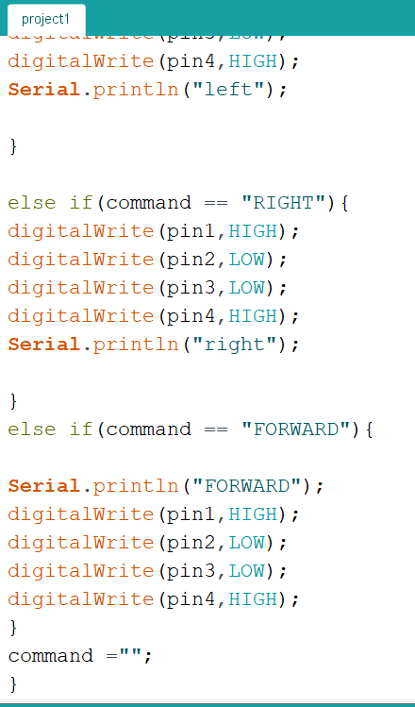

**IBM WATSON(NODE RED) AND MIT APP INVERSTORE:**

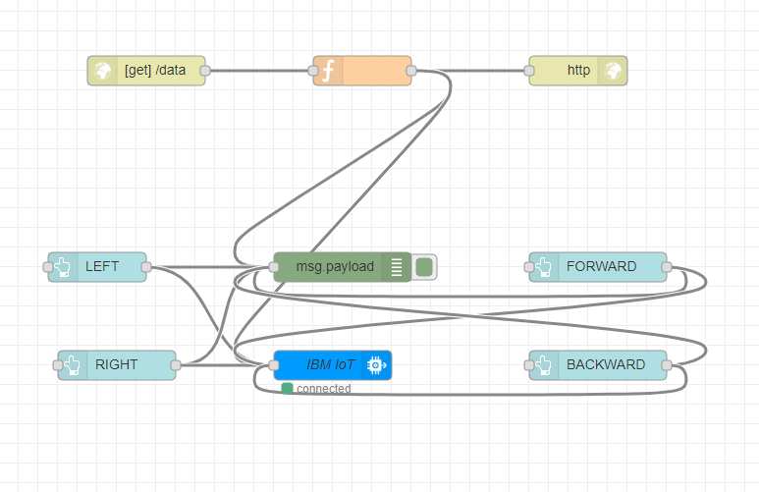

**MIT APP INVERSTORE:**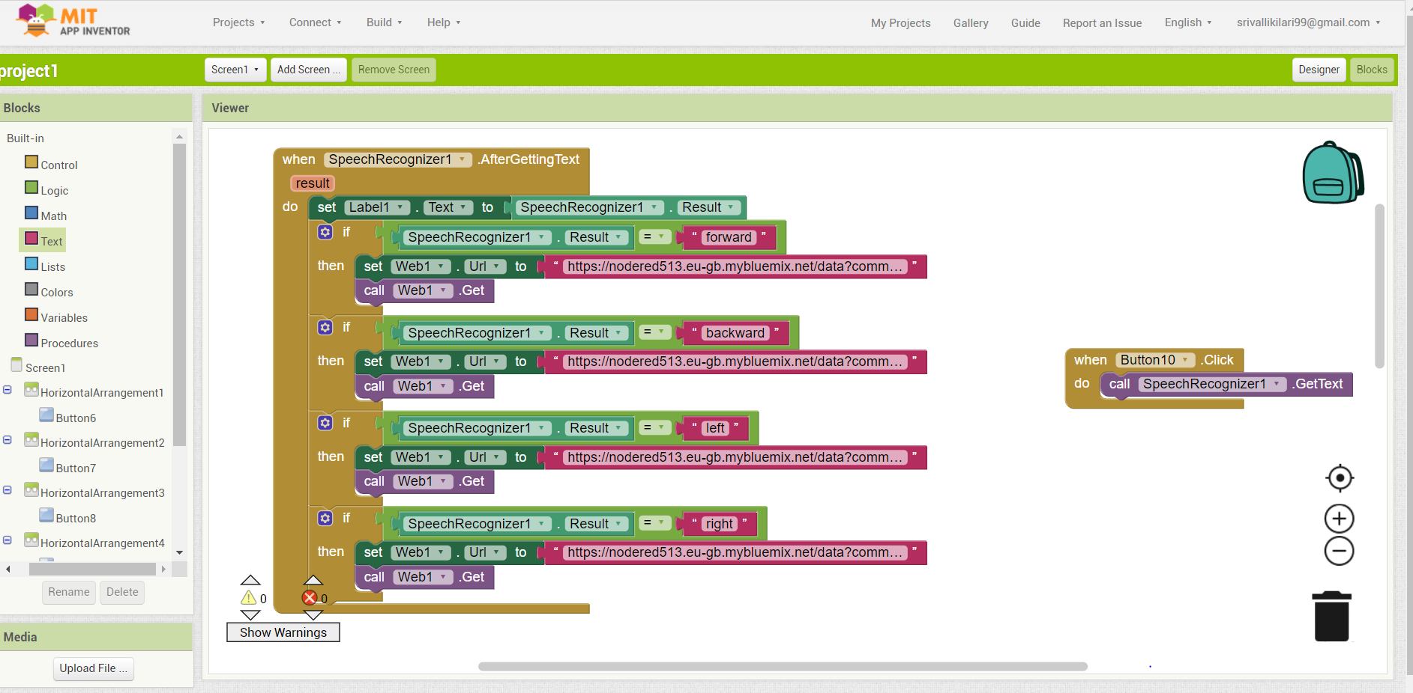

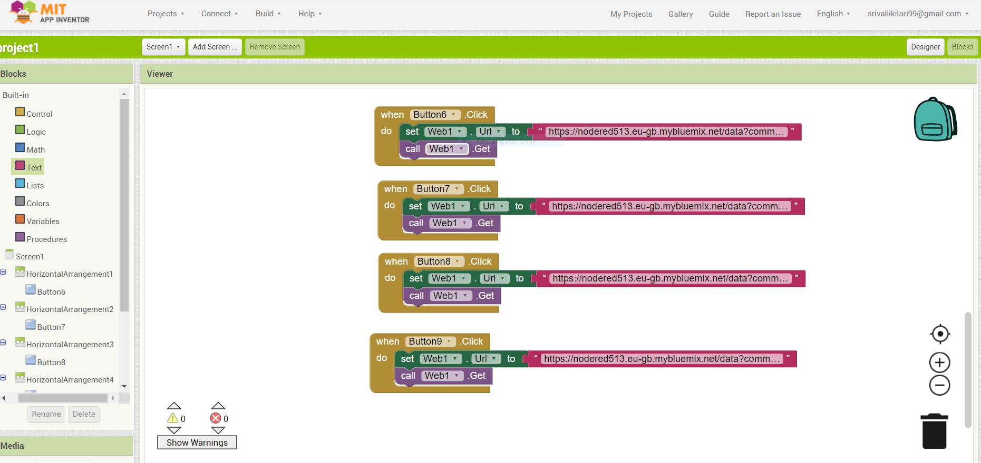

**APPLICATION UI:**

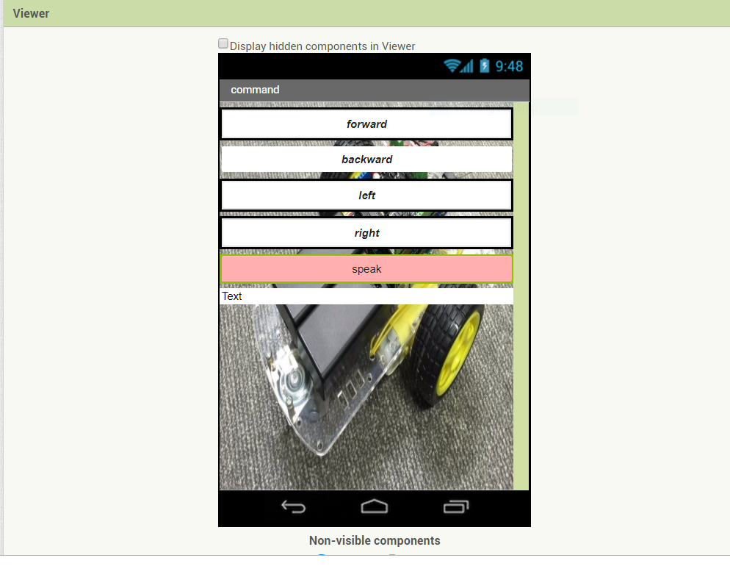

**OUTPUT AND SCREENSHOOTS:**

